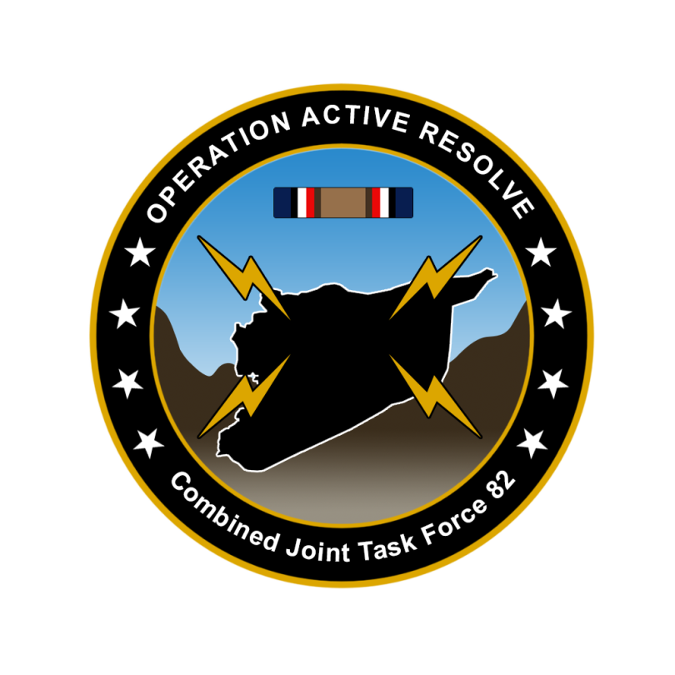

CJTF-82 OPERATION ORDER

OPERATION ACTIVE RESOLVE

# SITUATION

## Friendly situation

TBD

Briefly describe land, maritime, air and SOF.

## Enemy situation.

TBD

Big picture enemy situation

* Syrian major units (corps)
* Terror groups
* Insurgent groups

# MISSION

CJTF-82 are to deter SYRIAN aggression into TURKEY and ISRAEL in order to (IOT) maintain the integrity of international border. If deterrence fail CJTF-82 will

# EXECUTION

## Commander CJTF-82 intent.

### Purpose.

### End state.

## CONCEPT OF OPERATIONS

Operation Active Resolve will be conducted in 4 phases:

Phase 1: Shaping

Phase 2: Neutralize Syrian offensive capability

Phase 3: Stabilization

Phase 4: Transition

### Phase 1:

Set conditions for CJTF land offensive into Syrian to destroy Syrian offensive capability.

JFACC supported commander

### Phase 2:

Attack Syrian forces within Syria in order to neutralize Syrian offensive capability

LCC supported commander

### Phase 3:

Once Syrian offensive capability is neutralized, focus will shift to stabilize the situation and prepare for transition back to

### Phase 4:

## TASKS:

### Land Component Command (LCC):

COM LCC will…

* Build up forces
* On order (O/O) conduct ground offensive into Syria in order to neutralize Syrian offensive capability to conduct offensive operations,

### Maritime Component Command (MCC):

COM MCC will…

* Maintain sea control outside Israel/Turkey and Syria in order to prevent any interference from CJTF-82 operations.

### Joint Force Air Component Command (JFACC):

COM JFACC will..

* Maintain air superiority over Turkey/Israel
* Establish Air superiority over Syria
* Conduct AI campaign to break the Syrian will and capability to conduct offensive operations

### Special Operations Component Command (SOCC):

COM SOCC will conduct full spectrum special operations in order to :

* Facilitate for CJTF-82 targeting
* Facilitate for counterinsurgency operations
* Facilitate for counter terrorism operations

# ADMINISTRATION AND LOGISTICS

# COMMAND AND CONTROL

CJTF-82 HQ located at Ramat David Airbase

# ANNEXES

* CJTF-82 Target list (master target list)